­­

**Admin Migration Utility**

March 23, 2017 - Version 1.0

Contents

[1 Overview 3](#_Toc471726337)

[1.1 Supported Versions 3](#_Toc471726338)

[1.2 Category 3](#_Toc471726339)

[1.3 Special Considerations 3](#_Toc471726340)

[2 Deployment 5](#_Toc471726341)

[3 Input and Preparation 5](#_Toc471726342)

[3.1 Installing the Relativity application 5](#_Toc471726343)

[3.2 Creating manager and worker agents 6](#_Toc471726344)

[4 Export Utility Job 6](#_Toc471726345)

[4.1 Viewing export errors 8](#_Toc471726346)

[5 Import Utility Job 9](#_Toc471726347)

[5.1 Viewing import errors 10](#_Toc471726348)

[5.2 Creating a User import file 11](#_Toc471726349)

[5.3 Viewing import errors 15](#_Toc471726350)

[5.4 Importing users from Relativity 9.3 and below 16](#_Toc471726351)

[5.4.1 Importing users using an RUIA 14.8 import file 16](#_Toc471726352)

[5.4.2 Importing users using an RUIA 18.1 import file 17](#_Toc471726353)

[6 Viewing the Queue tab 17](#_Toc471726354)

[7 Performance Metrics 19](#_Toc471726355)

[8 Appendix A 19](#_Toc471726356)

[8.1 Using the Forgot Your Password? Link 19](#_Toc471726357)

[9 Appendix B 21](#_Toc471726358)

[9.1 Enabling the Forgot Your Password? Link 21](#_Toc471726359)

[10 Appendix C 23](#_Toc471726360)

[10.1 Reset a System Administrator Password 23](#_Toc471726361)

[11 Disclaimer 24](#_Toc471726362)

1. Overview

You can use the Relativity Admin Migration Utility to import multiple users into Relativity from a CSV file by defining the users and their Relativity settings. You can also export a list of users from your environment along with their Relativity settings.

* 1. Supported Versions

This solution is supported in Relativity 9.4.

* 1. Category

This custom solution consists of the following components:

Relativity Application

* + Custom Agents
  + Event Handlers
  + Custom Pages
  1. Special Considerations

Passwords cannot be imported or exported with this application. Upon import, users who only have default password providers will be required to click the **Forgot your password?** link on the login page to generate a new password in order to access Relativity. Please refer to **Appendix A** for a walkthrough of the user process to reset their own individual passwords. Please refer to **Appendix B** for instructions to enable the **Forgot your password?** link **o**n the login page. Imported users who are in the System Administrators group will not be able to use the **Forgot your password?** link. Please see **Appendix C** for direction on resetting a System Administrator password.

All users imported with this application will have a Default Password Provider automatically created and associated with their account. System Administrators can restrict newly imported users from using the **Forgot your password?** workflow and thus restrict access to Relativity with the Default Password Provider by setting the **CanChangePassword** column in the load file to false.

The **Forgot your password?** workflow will not work if **CanChangePassword** setting is set to FALSE.

**Only Default Password Provider and Default Integration Authentication Provider Authentication types are supported. All other authentication types are unsupported and won’t be exported or imported using this tool.**

* + Example: A system admin attempts to export a user who has the following login methods:
    - Default Password Provider
    - Default Integration Authentication Provider
    - Default RSA Provider

The user will be exported however only with the Login Methods supported by this solution which are Default Password Provider and Default Integration Authentication Provider. The Default RSA Provider will not be exported and cannot be imported with this solution.

* + Example: A system admin attempts to export a user who has the following login method:
    - Default RSA Provider

The user will be exported however without any Login Methods because Default RSA Provider is not supported. Upon import a Default Password Provider will be automatically created for this user however the user will not be able to login until they complete the **Forgot your password?** workflow. Admins can control a user’s ability to change their password with the **CanChangePassword** column in the load file.

During import an error that reports a user may be partially imported indicates that one of the user creation steps failed. We recommend validating the user’s personal information, keywords and notes and login methods. Update the user information as needed or remove the user and retry the import if necessary.

Worker queue records are removed sequentially as job errors are recorded therefore the total number of imported/exported records reported in between web page refreshes may not be fully accurate until the job is completely processed.

If the import file contains Relativity Admin or Relativity Service Account, and error will most likely occur because all Relativity instances already have these accounts.

The Admin Migration application can only be installed in one workspace in your environment.

This application only works during off hours.

When creating an import load file, a column header row must be included in the load file for import jobs and each column header must be populated with a value.

Relativity throws an error if you try to import a user that already exists in your environment.

When an import or export job is deleted, all errors that correspond to that job are also deleted.

If there are multiple groups in the instance you export from and the instance you import to, users are only imported into the first duplicate name group created.

Every user is automatically added to the “Everyone” group, even in scenarios where the group column in the load file is blank.

If Trusted IP for the user is empty or blank, the Outside Trusted IPs setting for two factor mode is invalid and won’t work.

If the application is uninstalled from your environment, the agents that you manually created remain in the environment, but they will fail and disable as required tables are removed.

This application does not support sending emails in environments with encrypted SMTP passwords.

Uninstalling the application will delete all the database tables, queue records, existing export/import jobs.

1. Deployment

To deploy and configure the solution, you must first add it to the Application Library as a Relativity application. You can then install and configure the solution in a workspace.

**Note:** Only install the Admin Migration application to one workspace in your environment.

To add the application to the Application Library:

Log in to Relativity.

Click the user drop-down menu in the upper-right corner of Relativity, then click **Home**.

Click the **Applications & Scripts** tab, then click the **Application Library** tab.

Click **Upload Application**.

Click **Browse**, navigate to and select the **.rap** file, and then click **Open**.

Click **Save**.

1. Input and Preparation

After you add the application to the Application Library, you’re ready to install and configure it in a workspace by performing these basic tasks:

Install the solution application to a single workspace from the Application Library.

Create manager and worker agents.

* 1. Installing the Relativity application

To install the Relativity application in the workspace:

1. Click the user drop-down menu in the upper-right corner of Relativity, then click Home.

Click the Applications & Scripts tab, then click the Application Library tab.

Click the name of the Admin Migration Utility application.

Under Workspaces Installed, click Install.

Click C:\Flare Projects\Recipes and Applications\Content\Resources\Images\Performance Dashboard\ICN_Ellipsis.png next to Workspaces.

Select the destination workspace and click Ok.

Click Save.

* 1. Creating manager and worker agents

To use the Admin Migration Utility application, you must add the following manager and worker agents to your environment;

AdminMigrationUtility - Export Manager

AdminMigrationUtility - Export Worker

AdminMigrationUtility - Import Manager

AdminMigrationUtility - Import Worker

To create manager and worker agents, perform the following steps:

1. Click the user drop-down menu in the upper-right corner of Relativity, and then click **Home**.
2. Navigate to the **Server & Agent Management** tab, and then select **Agents**.
3. Click **New Agent**.
4. Click C:\Flare Projects\Recipes and Applications\Content\Resources\Images\Performance Dashboard\ICN_Ellipsis.png next to **Agent Type**, and then filter in the Application Name column for Admin Migration Utility.
5. Select **AdminMigrationUtility - Export Manager**.
6. Click **Ok**.

You can only create one instance of the manager agents. You can create multiple worker agents.

1. Set the number of manager agents you want in the **Number of Agents** field.
2. Click C:\Flare Projects\Recipes and Applications\Content\Resources\Images\Performance Dashboard\ICN_Ellipsis.png next to **Agent Server**, and then select the agent server where you want to install the new agent.
3. Click **Ok**.
4. Set the appropriate interval.
5. Leave all other settings at their default values, and then click **Save and New**.
6. Repeat steps 1-11 for the other manager and worker agents.

You must install at least one each agent for all four agent types.

1. Export Utility Job

You can create and run an export utility job from the Export Utility Job tab. To create and run an export utility job, complete the following workflow:

1. Click **New Export Utility Job**.
2. Complete the following fields:
   * **Name** - enter a name for your export job.
   * **Object Type** - select **User**.
   * **Priority** - (optional) enter a priority for your export job. The lower the number, the higher the priority. Negative numbers are acceptable.
   * **Confirmation notification** - enter a comma delimited list of email addresses to send a notification to once the export utility job completes.
3. Click **Save**.
4. From the Manage Export Job console, click **Submit**.

Once you click **Save**, the Status section populates with the following information:

* **Status** - the status of the export utility job.
* **Created On** - the date and time the export utility job was created.
* **Created By** - the name of the user who created the export utility job.
* **System Last Modified On** - the date and time the export utility job was last modified.
* **System Last Modified By** - the name of the user who last modified the export utility job.

After you click **Submit**, Relativity agents begin processing your export utility job. The Progress section populates with the following information:

* **Expected** - the expected number of users to be exported.
* **Records That Have Been Processed** - the number of users whose data has been prepared for export. This number is updated as the page refreshes.
* **Exported** - the number of users exported in the export file
* **Not exported** - the number of users not exported in the export file.

Click **Cancel** to stop the job from running. You can monitor the manager and worker agents from the **Queue** tab. For more information, see [Viewing the Queue tab](#Queue_tab).

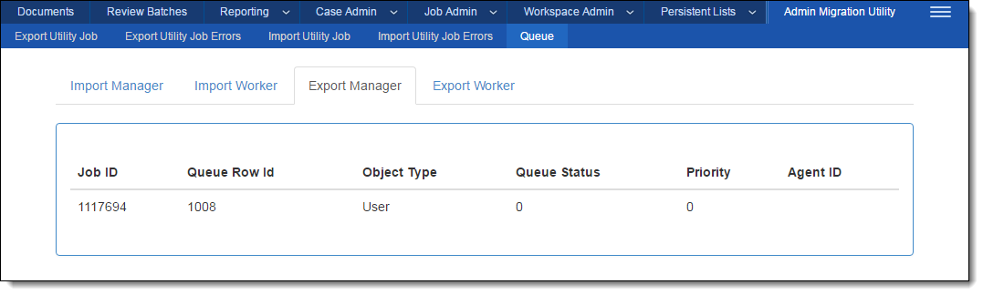

Once the agents finish the export, Relativity populates the **Export File** field on the export utility job with a CSV file that contains a list of users and their Relativity settings for the object type you specified. Click the file name to download your export file.

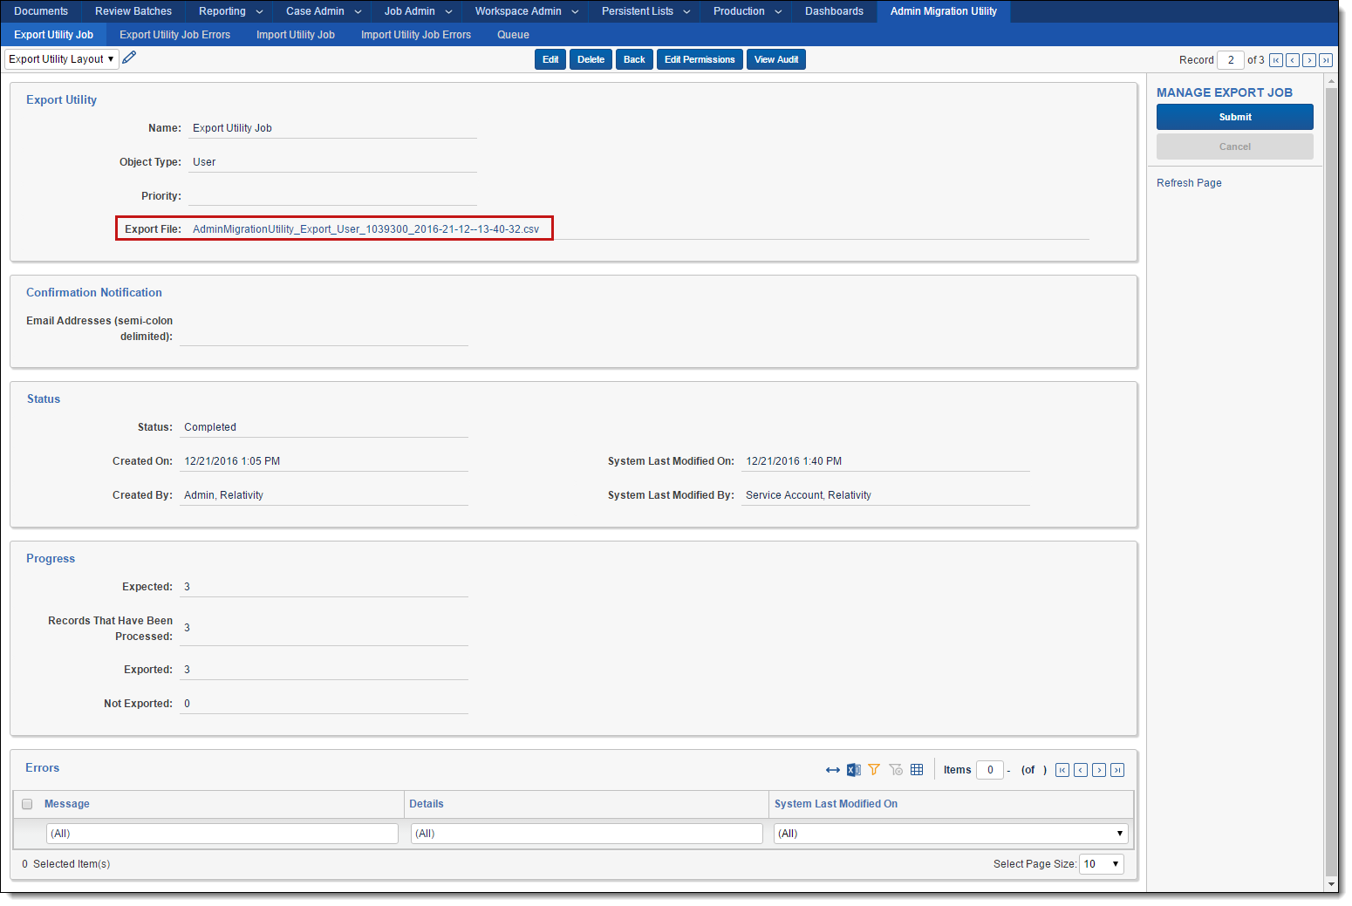

* 1. Viewing export errors

You can view export errors on the **Export Utility Job Errors** tab. Errors are also linked to your export utility job.

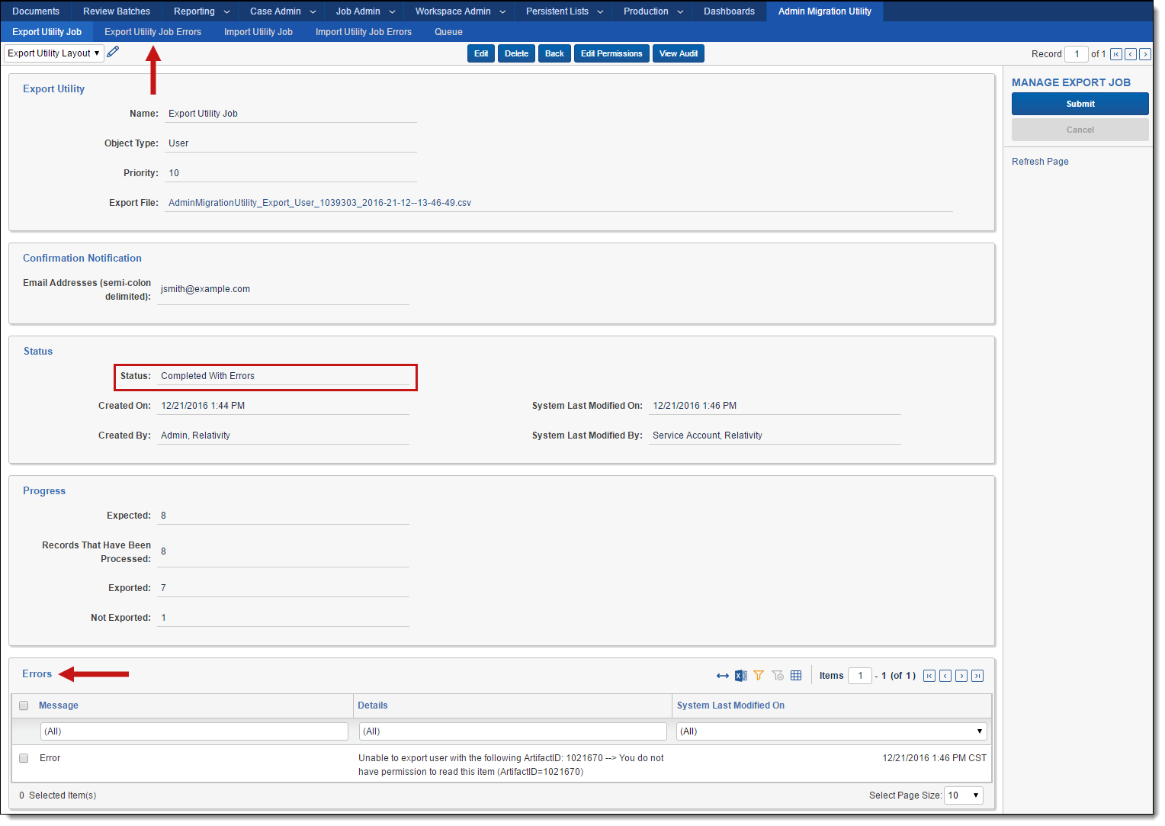

1. Import Utility Job

You can run an import utility job from the Import Utility Job tab. To run an import utility job, complete the following workflow:

1. Click **New Import Utility Job**.
2. Complete the following fields:
   1. **Name** - enter a name for your import job.
   2. **Object Type** - select **User**.

**Note:** Once you select an object type from the drop down, click **Download User Template** to download a template you can populate with the user data you want to import.

**Note:** To import an import file generated by the Relativity User Import Application (RUIA) in a version of Relativity below Relativity 9.4, see [Importing users from Relativity 9.3 and below](#Importing_users_from).

* 1. **Priority** - (optional) enter a priority for your import job.
  2. **Import File** - select the object file you want to import. You can also select the template you downloaded and populated with your object data. For more information, see [Creating a User import file](#User_import_file).

1. (Optional) Under **Confirmation Notification**, enter any email addresses that you want to send a confirmation notification to once the import completes. Separate each entry with a comma.
2. Click **Save**.
3. (optional) Click **Validate** to validate your import file before you import your users. If there are any errors, you can view them in the **Errors** section and on the **Import Utility Job Errors** tab. For more information, see [Viewing import errors](#Viewing_import_errors).
4. Click **Submit** to validate and import your file. Clicking **Submit** validates file against user information in Relativity.

Once you click **Save**, the Status section populates with the following information:

* **Status** - the status of the export utility job.
* **Created On** - the date and time the export utility job was created.
* **Created By** - the name of the user who created the export utility job.
* **System Last Modified On** - the date and time the export utility job was last modified.
* **System Last Modified By** - the name of the user who last modified the export utility job.

After you click **Submit**, Relativity runs your import job. Click **Cancel** to stop the job from running.

**Progress**

* **Expected** - the expected number of users to be imported.
* **Imported** - the number of users imported via the import file
* **Not imported** - the number of users not imported to Relativity.

Click **Cancel** to stop the job from running. You can monitor the worker and manager agents from the **Queue** tab. For more information, see [Viewing the Queue tab](#Queue_tab).

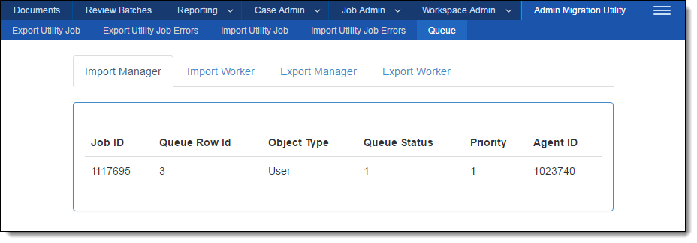

* 1. Viewing import errors

You can view export errors on the **Import Utility Job Errors** tab. Errors are also linked to your import utility job.

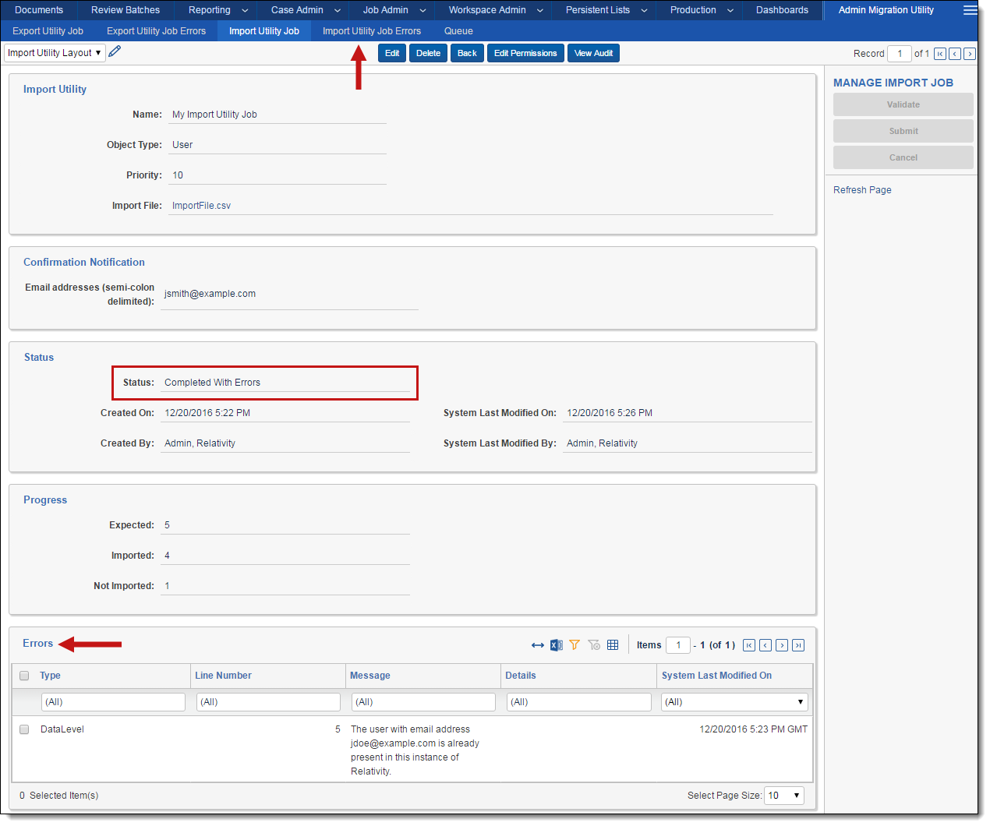

* 1. Creating a User import file

To import users into Relativity using the Admin Migration Utility, you must create a load file which contains the users to import. You can download a template load file by clicking **New Import Utility Job**, selecting an object type from the Object Type drop-down, and then clicking **Download UserTemplate**.

The User template contains the following fields:

1. FirstName
   1. **Required**
   2. **Type:** String
   3. **Description:** The user’s first name.
   4. **Notes:** If the first name is greater than 50 characters. The application will throw an error to truncate user’s first name to 50 characters.
2. LastName
   1. **Required**
   2. **Type:** String
   3. **Description:** The user’s last name.
   4. **Notes:** This field can’t contain more than 50 characters. The application will throw an error to truncate user’s Last name to 50 characters.
3. EmailAddress
   1. **Required**
   2. **Type:** String
   3. **Description:** The user’s email address.
   4. **Notes:** Relativity users can have the same first and last name, but the email address must be unique.
4. Keywords
   1. **Optional**
   2. **Type:** String
   3. **Description:** Any keywords related to the user.
   4. **Notes:** This field can’t contain more than 50 characters. The application will throw an error to truncate Keywords to 50 characters.
5. Notes
   1. **Optional**
   2. **Type:** String
   3. **Description:** Any notes related to the user.
6. Groups
   1. **Optional**
   2. **Type:** String
   3. **Description:** A semi-colon delimited list of group names to add the user to.
   4. **Example:** Reviewer Group; Attorney Group
   5. **Notes:** By default, all users are added to the “Everyone” group even if this field is left blank.
7. Type
   1. **Required**
   2. **Type:** String
   3. **Description:** The user type. The default values are Internal or External, but you can populate this field with any value that exists in the environment where the users will be imported.
8. Client
   1. **Required**
   2. **Type:** String
   3. **Description:** The client associated with the user.
   4. **Notes:** If more than one client exists with the same name, the user won’t be created.
9. RelativityAccess
   1. **Required**
   2. **Type:** Boolean - TRUE or FALSE
   3. **Description:** The settings used to control the user’s access to Relativity. If set to TRUE, Enabled users can to log in to Relativity and are considered for billing under your Relativity license. If set to FALSE, users cannot access Relativity and won't be counted or billed as named users on your Relativity license.
10. DocumentSkip
    1. **Required**
    2. **Type:** Single choice
    3. **Description:** Controls whether or not the user has the ability to skip documents during review that no longer meet the original conditions of a view due to propagation. Enter one of the following values:
       1. **Enabled** - enables the Skip function.
       2. **Disabled** - disables the Skip function.
       3. **Force Enabled** - always enables the Skip function so that the user can't turn it off. This option is only available for system admins.
11. BetaUser
    1. **Required**
    2. **Type:** Boolean - TRUE or FALSE
    3. **Description:** Indicates whether Fluid UI is enabled for the user. At the time of writing, users will always have the fluid UI enabled no matter the value of this field in the load file.
12. ChangeSettings
    1. **Required**
    2. **Type: Boolean** - TRUE or FALSE
    3. **Description:** Allows users without admin rights to change their settings.
13. KeyboardShortcuts
    1. **Required**
    2. **Type: Boolean** - TRUE or FALSE
    3. **Description**: Enables or disables access to the keyboard icon in the core reviewer interface.
14. ItemListPageLength
    1. **Required**
    2. **Type:** Whole number - enter a value between 1 and 200.
    3. **Description:** A numeric field indicating the default list length for all views in Relativity.
15. DefaultSelectedFileType
    1. **Required**
    2. **Type:** Single choice
    3. **Description:** The default viewer mode. Enter one of the following values:
       1. Viewer
       2. Native
       3. Image
       4. Long Text
       5. Production
16. SkipDefaultPreference
    1. **Required**
    2. **Type:** String
    3. **Description:** The skip default preference. Enter one of the following values:
       1. **Skip** - advances a user to the next document in the queue that matches the defined view conditions when the user clicks Save and Next.
       2. **Normal** - document review operates normally, displaying all documents in the queue.
17. EnforceViewerCompatibility
    1. **Required**
    2. **Type:** Boolean - enter TRUE or FALSE
    3. **Description:** Provides you with the ability to control when users are required to download a new version of the viewer.
18. AdvancedSearchPublicByDefault
    1. **Required**
    2. **Type:** Boolean - enter TRUE or FALSE
    3. **Description:** Indicates whether saved searches created by the user are public by default.
19. NativeViewerCacheAhead
    1. **Required**
    2. **Type:** Boolean - enter TRUE or FALSE
    3. **Description -** If enabled, pre-loads the next native document in the review queue once the active document is loaded.
    4. **Notes:** To utilize Native Viewer Cache Ahead, you must have version 5.04 or greater of the viewer running on your computer. If this application isn't working properly, uninstall and reinstall your viewer to ensure compatibility.
20. ChangeDocumentViewer
    1. **Required**
    2. **Type:** Boolean - enter TRUE or FALSE
    3. **Description:** Allows users to select which viewer they want to use.
    4. **Notes:** If set to False, the user can only use the viewer set in the Document Viewer field.
21. DocumentViewer
    1. **Required**
    2. **Type:** String
    3. **Description:** Determines which viewer the user can access when reviewing documents. Enter one of the following values:
       1. **Default** - only available in Internet Explorer. This option pulls the from the UseLegacyViewer instance setting to determine which viewer the user can access.
       2. **HTML** - uses the HTML viewer to review documents.
       3. **ActiveX** - uses the ActiveX viewer to review documents.
22. WindowsAccount
    1. **Optional**
    2. **Type:** String
    3. **Description:** The windows account data for the user. This is the name of the user account in Active Directory.
    4. **Notes:** This value can be specified as a SAM Account (domain\username) or as a UPN (user@fully-qualified-domain).
23. UserMustChangePasswordOnNextLogin
    1. **Required**
    2. **Type:** Boolean - enter TRUE or FALSE
    3. **Description:** Indicates whether a user must update the Relativity password on next login.
24. CanChangePassword
    1. **Required**
    2. **Type:** Boolean - enter TRUE or FALSE
    3. **Description:** Enables the user to change their password.
25. MaximumPasswordAgeInDays
    1. **Required**
    2. **Type:** Whole number - enter a value between 0 and 1000
    3. **Description:** Sets the maximum number of days a password remains valid. The user will be prompted for a new password on a logon at the expiration date. If set to zero, the password does not expire.
26. TwoFactorMode
    1. **Optional**
    2. **Type:** Single choice - enter None, Always, Outside Trusted IPs
    3. **Description:** Determines when Two Factor authentication is used.
27. TwoFactorInfo
    1. **Optional**
    2. **Type:** String
    3. **Description:** Enter a valid email address if TwoFactorMode is set to Always or Outside Trusted IPs.
    4. **Notes:** If TwoFactorMode is None, you don’t need to enter a valid email address for this field.
    5. Viewing import errors

You can view import errors on the **Import Utility Job Errors** tab. Errors are also linked to your import utility job.

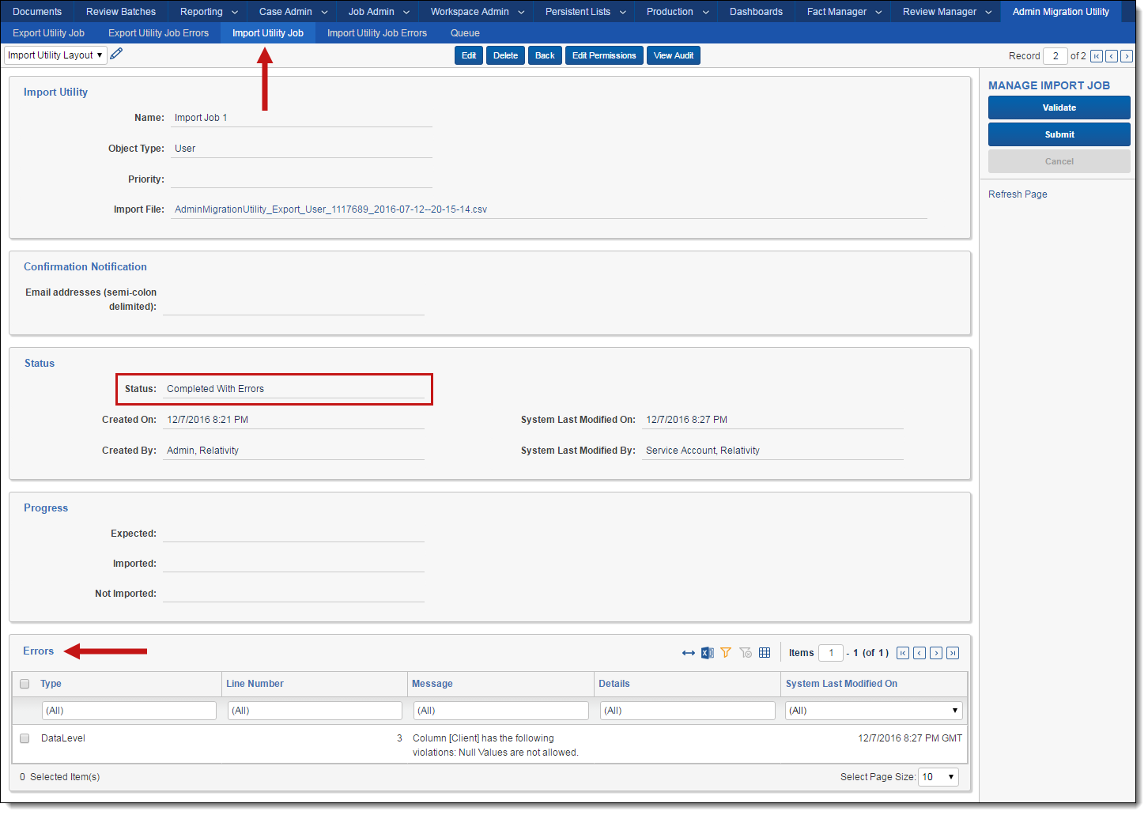

**Note:** Errors that report a user being partially imported indicate that the user was created, but the application was unable to update one of the user’s properties. We recommend deleting the reported user and attempting the import again.

* 1. Importing users from Relativity 9.3 and below

Use the following workflows to import an import file generated by the Relativity User Import Application (RUIA) in a version of Relativity below Relativity 9.4. The workflow you use depends on the version of the RUIA you are using, either version 14.8 or 18.1.

* + 1. Importing users using an RUIA 14.8 import file

To import users into Relativity 9.4 using an RUIA 14.8 import file, complete the following in your import file:

1. Rename the **AuthenticationData** column to **WindowsAccount**.
2. Remove the **Password** column completely.
3. Rename the **ChangePassword** column to **CanChangePassword**.
4. Rename the **MaximumPasswordAge** column to **MaximumPasswordAgeInDays**.
5. Remove the **Data Focus** column completely.
6. Add the following columns and to the import file, and populate for each user:
   * **ChangeDocumentViewer** - enter **TRUE** or **FALSE**
     1. If **TRUE**, users can select viewer they want to use. You can still set a default viewer in the Document Viewer field, but users can switch between viewers.
     2. If **FALSE**, users cant’ select which viewer they want to use. Whatever viewer appears in the Document Viewer field is the only viewer the user has access to.
   * **DocumentViewer** - Enter one of the following values:
     1. **Default -** only available in Internet Explorer. This option pulls the from the UseLegacyViewer instance setting to determine which viewer the user can access.
     2. **HTML -** uses the HTML viewer to review documents.
     3. **ActiveX -** uses the ActiveX viewer to review documents.
   * **UserMustChangePasswordOnNextLogin** - enter **TRUE** or **FALSE**.
     1. If **TRUE** users must change the password when the log in.
     2. If **FALSE** users don’t need to change the password when they login.
   * **TwoFactorMode** - Enter one of the following values to determine when to use two factor authentication:
     1. **None**
     2. **Always**
     3. **OutsideRestrictedIPs**.
   * **TwoFactorInfo** - If TwoFactorMode is **Always** or **OutsideRestrictedIPS**, enter a valid email address for this field.
     1. Importing users using an RUIA 18.1 import file

To import users into Relativity 9.4 using an RUIA 18.1 import file, complete the following in your import file:

1. Add the following columns and default values to the import file:
   * ChangeDocumentViewer - enter TRUE FALSE
     1. If **TRUE**, users can select viewer they want to use. You can still set a default viewer in the Document Viewer field, but users can switch between viewers.
     2. If **FALSE**, users cant’ select which viewer they want to use. Whatever viewer appears in the Document Viewer field is the only viewer the user has access to.
   * DocumentViewer - enter one of the following values:
     1. **Default -** only available in Internet Explorer. This option pulls the from the UseLegacyViewer instance setting to determine which viewer the user can access.
     2. **HTML -** uses the HTML viewer to review documents.
     3. **ActiveX -** uses the ActiveX viewer to review documents.
2. Viewing the Queue tab

You can view the progress of the worker and manager agent queues from the Queue tab.



The Queue tab contains the following fields:

* Job ID - the Artifact ID of the Import or Export Utility Job
* Queue Row Id - the ID column in the corresponding table
* Object Type - the type of object selected for the job
* Queue Status - the status of the current record. The following is a list of possible statuses:
  + -1: ERROR
  + 0: NOT\_STARTED
  + 1: IN\_PROGRESS
  + 2: COMPLETE
  + 3: CANCELLATION\_REQUESTED
  + 4: WAITING\_FOR\_WORKERS\_TO\_FINISH
  + 5: FINISHING\_JOB
* Priority - the priority for the job as set by the user
* Agent ID - the Artifact ID of the Agent processing the record

1. Performance Metrics

|  |  |  |
| --- | --- | --- |
| **Test** | **Test scenario** | **Operation time (hh:mm:ss)** |
| **Export** | 1 manager agent,  1 worker agent  1000 users | 00:08:37 |
| **Export** | 1 manager agent  5 worker agent  1000 users | 00:03:13 |
| **Validation** | 1 manager agent,  1 worker agent  1000 users | 00:20:48 |
| **Validation** | 1 manager agent  5 worker agent  1000 users | 00:07:34 |
| **Validation and Import** | 1 manager agent,  1 worker agent  1000 users | 01:16:55 |
| **Validation and Import** | 1 manager agent  5 worker agent  1000 users | 00:50:16 |

1. Appendix A
   1. Using the Forgot Your Password? Link

Newly imported users with a Default Password Provider should use the following workflow to set their own individual passwords. The **Forgot Your Password?** link does not work for users in the System Administrators group. System Administrators should follow **Appendix C** to reset their password.

1. Click the **Forgot Your Password?** link on the login page.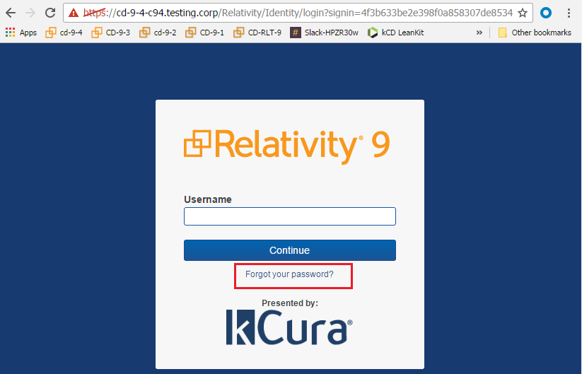
2. Enter the email address associated with the account and click on the button titled **Reset My Password.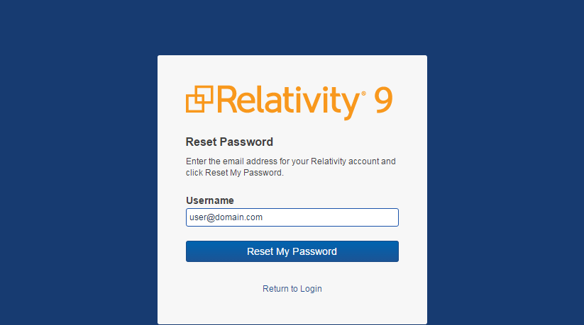**
3. An email will be sent to the entered email address. Click the **Reset Password** link in the email and create a new password fulling the requirements presented on the page. 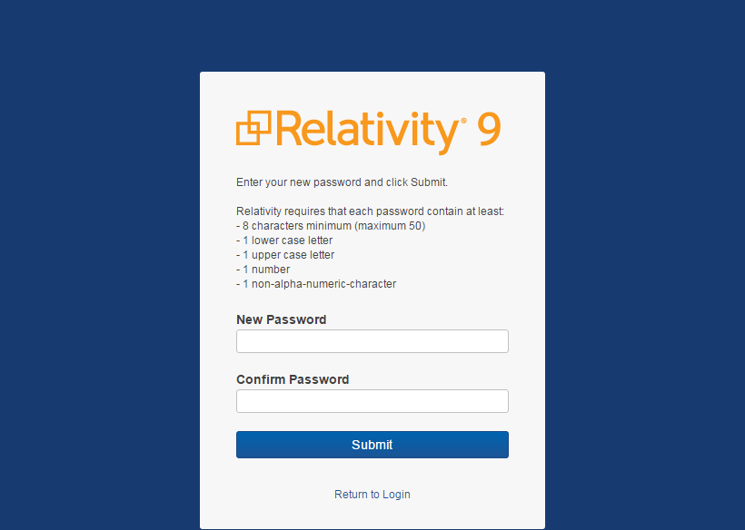
4. Click submit and the next page will confirm whether the reset was successful.
5. Afterwards the user will be able to login with their email address and their newly created password.
6. Appendix B
   1. Enabling the Forgot Your Password? Link

Newly imported users will not be able to login with their Default Password Provider until they reset the password using the **Forgot Your Password?** link on the login page. System Administrators can use the following steps to enable the **Forgot Your Password?** link on the login page.

1. Login to Relativity with a System Administrator account
2. Click on the **Authentication Provider** tab which is a child of the **Authentication** tab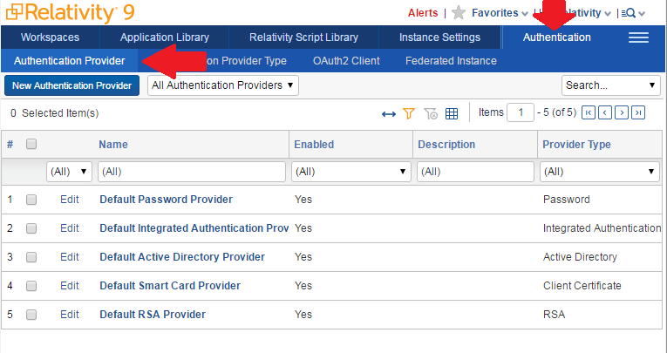
3. Click **Default Password Provider** and make sure **Allow Password Recovery via Email** is enabled.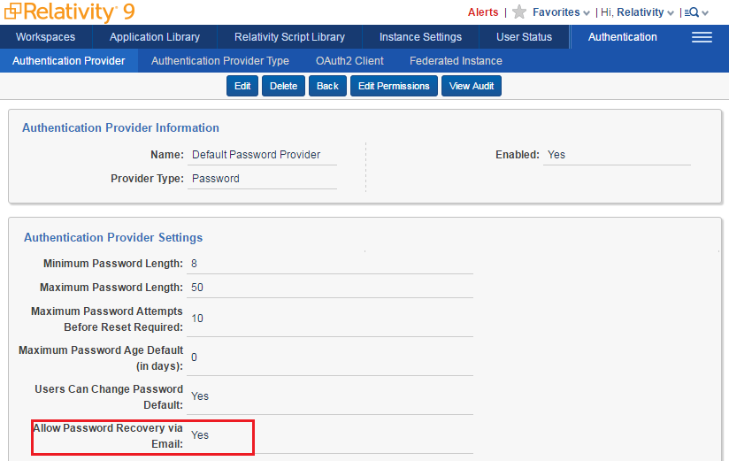
4. Appendix C
   1. Reset a System Administrator Password

Users in the System Administrator group cannot use the Forgot Your Password? link to reset their password. Another user must login as an existing administrator and take the following steps to allow an administrator to reset their password.

1. Login to Relativity using a System Administrator account
2. Navigate to the Users tab at the admin level
3. Click on the user who desires a password reset
4. Make sure the user has a **Default Password Provider**, create one if necessary
5. Click the button titled Send Password Reset Email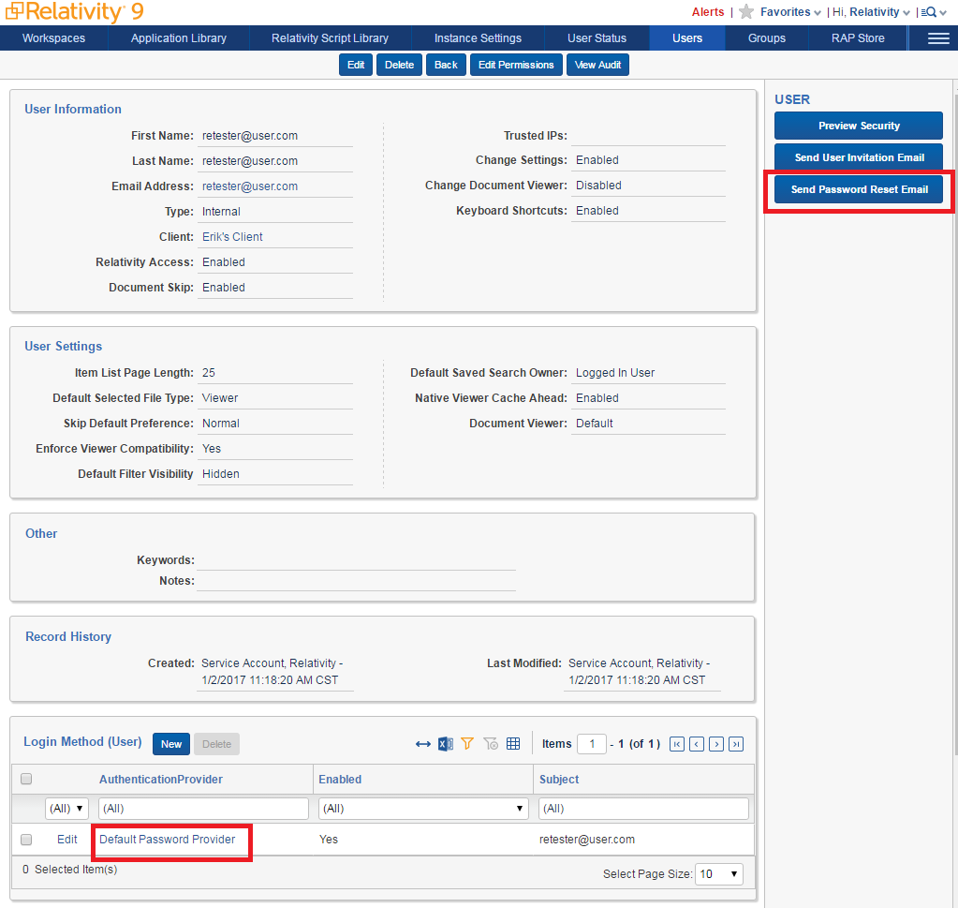
6. Afterwards the user will receive an email which will walk them through the necessary steps to reset their password.
7. Disclaimer

This solution is intended for use only in the Relativity versions specified in this document and run under the guidelines presented. While each solution is carefully built and thoroughly tested to work on the versions of Relativity specified in this document, this solution is not a core feature of Relativity and is not eligible for the same level of support as the Relativity platform.

In addition, custom components may not exhibit the same performance and behavior as native Relativity features. Custom solutions do not specify permission settings unless explicitly requested by the client.